Concept Map 1: Decision Support Systems (DSS)
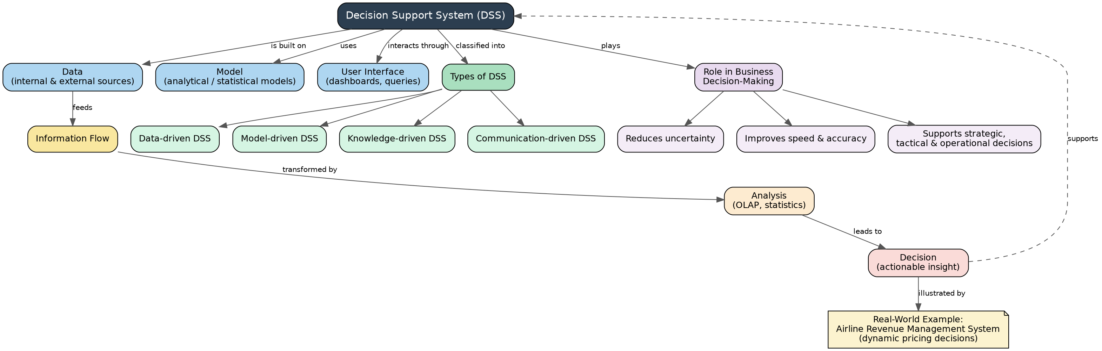

Concept Map 2: Operational Systems vs DSS
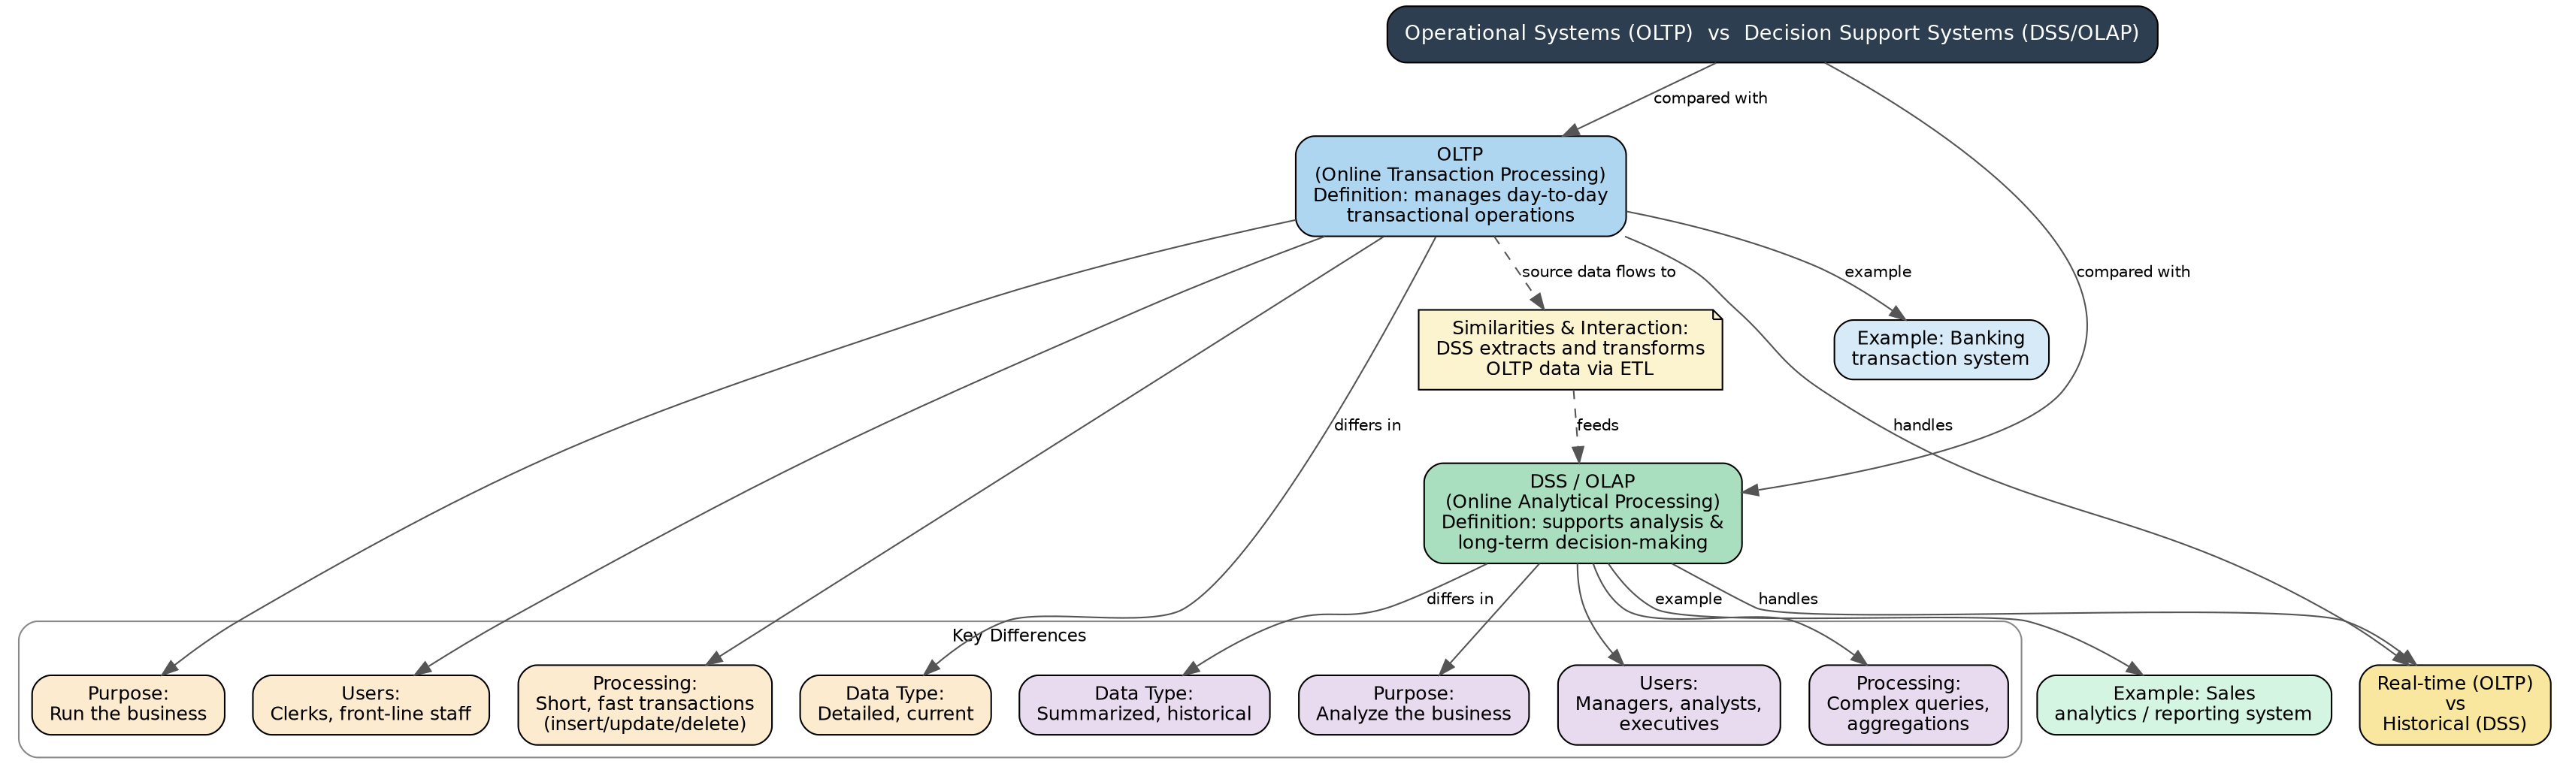

Concept Map 3: Architecture of Data Warehouse
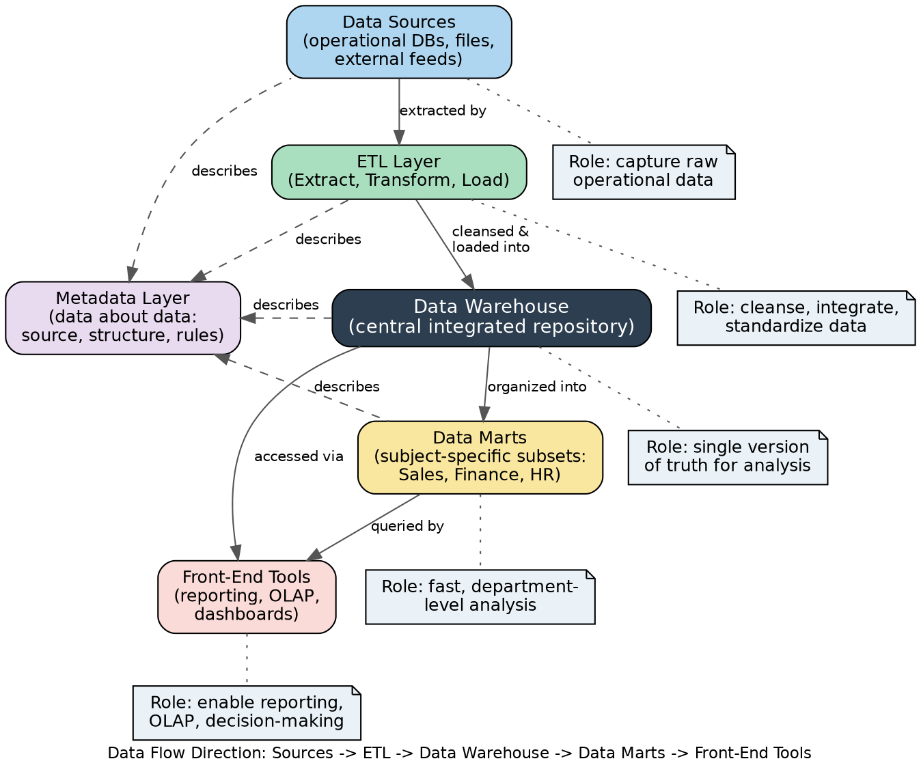

Concept Map 4: OLAP, Data Cubes & Dimensional Modelling
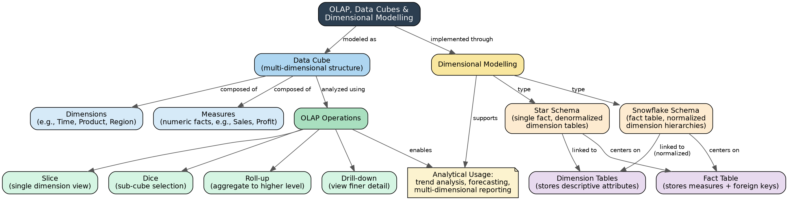

Concept Map 5: Query Processing & BI Tools (KNIME)
